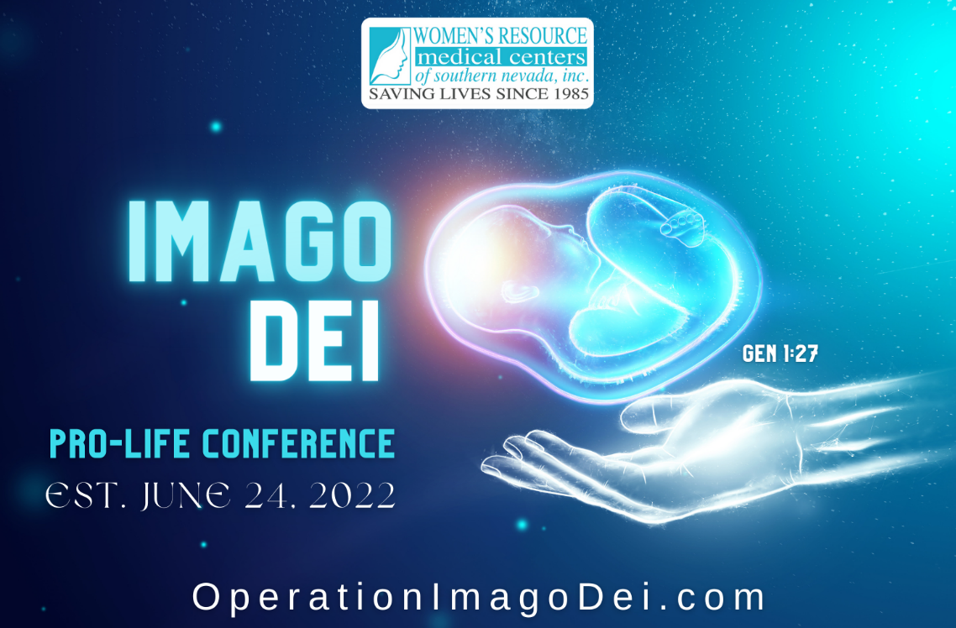
The First Annual Imago Dei Pro-Life Conference Will Take Place on
Saturday, August 20, 2022, at Boulder Creek Golf Course in Boulder City from 8 AM to 4 PM!
Only 300 Seats are Available, Get Yours Today!
The ticket Price is $20 and Includes Breakfast and Lunch.
There is a great need for us to strengthen our pro-life voice in a harmonious song that raises Truth to the surface of the muck and mire. Therefore, we are excited to announce that on Saturday, August 20, 2022, we will be conducting the First Annual Pro-Life Conference! The name of this annual conference will be Imago Dei, and after this year’s launch, you can mark your calendar for the closest Saturday to June 24 every year as we plan to hold this event in commemoration of victory day!

